


S-125
Published by the
International Hydrographic Organization
4b quai Antoine 1er
Principauté de Monaco
Tel: (377) 93.10.81.00
Fax: (377) 93.10.81.40
info@iho.int
www.iho.int
MARINE AIDS TO NAVIGATION (AtoN)

Edition 1.0.0 – December 2025

© Copyright International Hydrographic Organization December 2025
This work is copyright. Apart from any use permitted in accordance with the Berne Convention for the Protection of Literary and Artistic Works (1886), and except in the circumstances described below, no part may be translated, reproduced by any process, adapted, communicated or commercially exploited without prior written permission from the International Hydrographic Organization Secretariat (IHO Secretariat). Copyright in some of the material in this publication may be owned by another party and permission for the translation and/or reproduction of that material must be obtained from the owner.
This document or partial material from this document may be translated, reproduced or distributed for general information, on no more than a cost recovery basis. Copies may not be sold or distributed for profit or gain without prior written agreement of the IHO Secretariat acting for the IHO and any other copyright holders.
In the event that this document or partial material from this document is reproduced, translated or distributed under the terms described above, the following statements are to be included:
“Material from IHO publication [reference to extract: Title, Edition] is reproduced with the permission of the International Hydrographic Organization Secretariat (IHO Secretariat) (Permission No ……./…) acting for the International Hydrographic Organization (IHO), which does not accept responsibility for the correctness of the material as reproduced: in case of doubt, the IHO’s authentic text shall prevail. The incorporation of material sourced from IHO shall not be construed as constituting an endorsement by IHO of this product.”
“This [document/publication] is a translation of IHO [document/publication] [name]. The IHO has not checked this translation and therefore takes no responsibility for its accuracy. In case of doubt the source version of [name] in [language] should be consulted.”
The IHO Logo or other identifiers shall not be used in any derived product without prior written permission from the IHO Secretariat.

Revision History
Changes to this Product Specification are coordinated by the IHO Nautical Information Provision Working Group (NIPWG). New editions will be made available via the IHO web site. Maintenance of the Product Specification shall conform to IHO Technical Resolution 2/2007 (revised 2010).

Version Number | Date | Author | Purpose
0.0.1 | 2022-03-07 | IALA ARM S-201 TG | First Draft
0.0.2 | 2022-09-02 | IALA ARM S-201 TG | Updated various sections
0.0.3 | 2024-10.20 | IALA ARM S-201 TG | Updated various sections
1.0.0 | 2025-03-38 | IALA ARM S-201 TG | Updated data model to align with S-201
1.0.0 | 2025-12-10 | IHO/IALA Joint  S-125 TG | Updated various sections from the comments of S-125 TG

TABLE OF CONTENTS
1 Overview 6
1.1 Introduction 6
2 Reference 6
2.1 Informative 6
2.2 Normative 7
3 Terms, Definitions and Abbreviations 7
3.1 Terms and Definitions 7
3.2 Abbreviations 9
3.3 Use of Language 9
3.4 UML Notations 9
4 Specification Description 10
4.1 Informal Description of Data Product 10
4.2 Data product specification metadata 10
4.3 Product Specification Maintenance 11
4.3.1 Introduction 11
4.3.2 New Edition 11
4.3.3 Revisions 11
4.3.4 Clarification 11
4.3.5 Version Numbers 11
4.4 Specification Scope 12
5 Data product identification 12
6 Data Content and Structure 12
6.1 Introduction 12
6.2 Application Schema 13
7 Feature Catalogue 24
7.1 Introduction 24
7.2 Feature Types 24
7.2.1 Geographic 25
7.2.2 Meta 25
7.2.3 Feature Relationship 25
7.2.4 Information Types 25
7.2.5 Attributes 25
7.2.5.1 Simple Attributes 25
7.2.5.2 Complex Attributes 26
7.3 Geometric Representation 26
8 Coordinate Reference System (CRS) 26
8.1 Introduction 26
8.2 Horizontal reference system 27
8.3 Projection 27
8.4 Vertical coordinate reference system 27
8.5 Temporal reference system 27
8.6 Coverage of nautical products data and scale 27
9 Data Quality 27
10 Data Capture and Classification 28
10.1 Data Encoding and Product Delivery 28
10.1.1 Data Encoding 28
10.1.2 Types of Datasets 28
10.1.3 Content of Update Datasets 29
10.2 Encoding of Latitude and Longitude 29
10.3 Numeric Attribute Encoding 29
10.4 Text Attribute Values 29
10.5 Mandatory Attribute Values 29
10.6 Unknown Attribute Values 30
10.7 Structure of dataset files 30
10.8 Object identifiers 30
10.9 Data coverage 31
10.10 Data overlap 31
10.11 Data extent 31
11 Data Delivery 31
11.1 Data Product Delivery Information 31
11.1.1 Dataset loading 31
11.1.2 New editions 32
11.2 Dataset size 32
11.3 Exchange Set 32
11.4 Support Files 32
11.5 Support File Naming Convention 32
11.6 Dataset Naming Convention 33
11.7 Update dataset naming convention 33
11.8 Catalogue File Naming Convention 33
12 Dataset Maintenance 34
12.1 Introduction 34
12.2 Production process for base and update datasets 34
12.3 Dataset updates and cancellation 34
12.4 Support file updates 34
12.5 Feature and portrayal catalogues 34
12.6 Feature history, versions, and change tracking 34
12.7 Dataset encryption 35
13 Portrayal 35
14 Metadata 35
14.1 Introduction 35
14.2 Metadata classes 35

Overview

Introduction
This document has been produced by the IALA ARM Committee and the IHO Nautical Information Provision Working Group (NIPWG) in response to a requirement to produce an Aids to Navigation (AtoN) data that can be used as a Nautical Publication Information Overlay (NPIO) within an Electronic Chart Display and Information Systems (ECDIS). It is based on the IHO S-100 framework specification and the ISO 19100 series of standards. It is a vector product specification that is primarily intended for encoding the properties and status of AtoNs. AtoN datasets describe the list of AtoNs and status information like temporary changes, proposed changes, advance notice of changes and discrepancy. S-125 datasets would be a derivative of full AtoN information as the public facing information for use in ECDIS/ECS. In other words, S-125 datasets would be the digital equivalent of the extended list of lights including all/most AtoN in order to meet IMO SOLAS V requirements of having list of lights on board and serve as a continually updated list of AtoN.

Reference

Informative
The following normative documents contain provisions that, through reference in this text, constitute provisions of this document.

IHO S-100 IHO Universal Hydrographic Data Model Edition 5.2.0 (December 2024).
ISO 8601. 2004. Data elements and interchange formats - Information interchange - Representation of dates and times. 2004.
ISO 19101-2:2008 Geographic Information - Rules for Application Schema
ISO/TS 19103:2005 Geographic Information - Conceptual schema language
ISO 19106:2004 Geographic Information - Profiles
ISO 19107:2003 Geographic Information – Spatial schema
ISO 19109:2005 Geographic Information - Rules for Application Schema
ISO 19111:2003 Geographic information - Spatial referencing by coordinates
ISO 19115-1:2014, Geographic information – Metadata. Amended by Amendment 1, 2018
ISO 19115-2:2009 Geographic information - Metadata: Extensions for imagery and gridded data
ISO 19123:2005 Geographic information - Schema for coverage geometry and functions
ISO 19129:2009 Geographic information - Imagery gridded and coverage data framework
ISO 19131:2007 Geographic information - Data product specifications
ISO 19136:2007 Geographic Information – Geography Markup Language
ISO 19136-2:2015 Geographic Information – Geography Markup Language
ISO/TS 19139 Geographic Information – Metadata – XML schema implementation

Normative
The following informative documents provide additional information, including background information, but are not required to develop applications for data conforming to this specification.

ISO/IEC 19757-3 Information technology – Document Schema Definition Languages (DSDL) – Part 3 Rule-based validation – Schematron.
ISO 19115:2006 ISO 19115:2003 Geographic Information – Metadata. As amended by Amendment 1 (2006).
IHO S-101 IHO Electronic Navigational Chart Product Specification

Terms, Definitions and Abbreviations

Terms and Definitions
The S-100 framework is based on the ISO 19100 series of geographic standards. The terms and definitions provided here are used to standardize the nomenclature found within that framework, whenever possible. Modifications have been made when necessary.

application
manipulation and processing of data in support of user requirements (ISO 19101)

application schema
conceptual schema for data required by one or more applications (ISO 19101)

conceptual model
model that defines concepts of a universe of discourse (ISO 19101)

conceptual schema
formal description of a conceptual model (ISO 19101)

coverage
feature that acts as a function to return values from its range for any direct position within its spatial, temporal or spatiotemporal domain (ISO 19123)
EXAMPLE Raster image, polygon overlay, digital elevation matrix.

data product
dataset or dataset series that conforms to a data product specification

data product specification
detailed description of a dataset or dataset series together with additional information that will enable it to be created, supplied to, and used by another party
NOTE: A data product specification provides a description of the universe of discourse and a specification for mapping the universe of discourse to a dataset. It may be used for production, sales, end-use, or other purpose.

dataset
identifiable collection of data (ISO 19115)
NOTE: A dataset may be a smaller grouping of data which, though limited by some constraint such as spatial extent or feature type, is located physically within a larger dataset. Theoretically, a dataset may be as small as a single feature or feature attribute contained within a larger dataset. A hardcopy map or chart may be considered a dataset.

dataset series
collection of datasets sharing common characteristics (ISO 19115)

domain
well-defined set (ISO/TS 19103)
NOTE: Well-defined means that the definition is both necessary and sufficient, as everything that satisfies the definition is in the set and everything that does not satisfy the definition is necessarily outside the set.

feature
abstraction of real-world phenomena (ISO 19101)
NOTE: A feature can occur as a type or an instance. Feature type or feature instance will be used when only one is meant.

feature association
relationship that links instances of one feature type with instances of the same or a different feature type (ISO19110)

feature attribute
characteristic of a feature (ISO 19101-1:2014, 4.1.12)
E.g.1: A feature attribute named “color” can have an attribute value “green” which belongs to the data type “text”.

E.g.2: A feature attribute named length can have an attribute value “82,4” which belongs to the data type “real”.

Note 1: A feature attribute has a type name, a data type and a value domain associated to it. A feature attribute for a feature instance also has an attribute value taken from the value domain.

Note 2: In a feature catalogue a feature attribute can include a value domain but does not specify attribute values for feature instance.

Note 3: In UML, attribute associations and operations are representation types and are not fundamental to the type of a characteristic nor to the type of feature. All three are equally capable of representing the same characteristics of a feature. Every implementation of a characteristic is allowed to use the representation type that is most appropriate and can use several different representations for a single characteristic if required.
Feature associations and feature operations therefore are different types of feature attribute, the distinction between them being based on storage and access mechanism rather than semantics.

geographic data
data with implicit or explicit reference to a location relative to the Earth (ISO 19109)
NOTE: Geographic information is also used as a term for information concerning phenomena implicitly or explicitly associated with a location relative to the Earth.

Metadata
information about a resource (ISO 19115 – 1: 2014, 4.10).

model
abstraction of some aspects of reality (ISO 19109)

portrayal
presentation of information to humans (ISO 19117)
Note: Within the scope of this International Standard Portrayal is restricted to the portrayal of geographic information” (ISO 19117:2012; 4.20)

quality
totality of characteristics of a product that bear on its ability to satisfy stated and implied needs (ISO 19101)

universe of discourse
view of the real or hypothetical world that includes everything of interest (ISO 19101)

Abbreviations
This product specification adopts the following convention for symbols and abbreviated terms:

ASCII American Standard Code for Information Interchange
ECDIS Electronic Chart Display and Information Systems
ENC Electronic Navigational Chart
GML Geography Markup Language
IHO International Hydrographic Organization
IOC International Oceanographic Commission
ISO International Organization for Standardization
NIPWG Nautical Information Provision Working Group
NPIO Nautical Publication Information Overlay
UML Unified Modeling Language
URI Uniform Resource Identifier
URL Uniform Resource Locator
VTS Vessel Traffic Services
WMS Web Map Service
WFS Web Feature Service
www World Wide Web
WGS World Geodetic System
XML Extensible Markup Language
XSLT eXtensible Stylesheet Language Transformations
XSD XML Schema Definition

Use of Language

Within this document, including appendices and annexes:
- “Must” indicates a mandatory requirement.
- “Should” indicates an optional requirement, that is the recommended process to be followed but is not mandatory.
- “May” means “allowed to” or “could possibly” and is not mandatory.

UML Notations

In this document, conceptual schemas are presented in the Unified Modeling Language (UML). Several model elements used in this schema are defined in ISO standards or in IHO S-100 documents. In order to ensure that class names in the model are unique ISO TC/211 has adopted a convention of establishing a prefix to the names of classes that define the TC/211 defined UML package in which the UML class is defined.

Specification Description

Informal Description of Data Product
This section contains general information about the data product.

Title: Marine Aids to Navigation (AtoN)

Abstract: Marine Aids to Navigation (AtoN) datasets describe the list of AtoNs and status information like temporary changes, proposed changes, advance notice of changes and discrepancy. S-125 datasets would be a derivative of full AtoN information as the public facing information for use in ECDIS/ECS. In other words, S-125 Marine AtoN data would be the digital equivalent of the extended list of lights including all/most AtoN in order to meet IMO SOLAS V requirements of having list of lights on board and serves as a continually updated list of AtoN.

Content: Datasets conforming to this specification will contain list of AtoNs (excluding VTS) and status information like temporary changes, proposed changes, advance notice of changes and discrepancy.

Spatial Extent: Global coverage of maritime areas.

Specific Purpose: Describing list and status of AtoNs and to allow the producer to exchange AtoN datasets with interested stakeholders.

Data product specification metadata
This information uniquely identifies this Product Specification and provides information about its creation and maintenance. For further information on dataset metadata, see section 14.

Title: Marine Aids to Navigation (AtoN)

S-100 Version: 5.2.0

S-125 Version: 1.0.0

Date: 2025-04-02

Language: English

Classification: Unclassified

Contact: International Hydrographic Organization (IHO)
4 quai Antoine 1er,
B.P. 445
MC 98011 MONACO CEDEX
Telephone: +377 93 10 81 00
Telefax: + 377 93 10 81 40

URL: https://iho.int

Identifier: S-125

Maintenance: Amendments to this specification will be produced on a needs basis. For reporting issues with this specification which need correction, use the contact information.

Product Specification Maintenance

Introduction
Changes to S-125 will be released by the IHO as a new edition, a revision, or as a document that includes clarification. These are described below.

New Edition
New Editions introduce significant changes. New Editions enable new concepts, such as the ability to support new functions or applications, or the introduction of new constructs or data types. New Editions are likely to have a significant impact on either existing users or future users of S-125.

Revisions
Revisions are defined as substantive semantic changes. Typically, revisions will introduce change to correct factual errors or introduce necessary changes that have become evident as a result of practical experience or changing circumstances. A revision must not be classified as a clarification. Revisions could have an impact on either existing users or future users of this specification. All cumulative clarifications will be included with the release of approved corrections revisions.

Changes in a revision are minor and ensure backward compatibility with the previous versions within the same Edition. Newer revisions, for example, introduce new features and attributes. Within the same Edition, a dataset of one version could always be processed with a later version of the feature and portrayal catalogues. In most cases a new feature or portrayal catalogue will result in a revision of this specification.

Clarification
Clarifications are non-substantive changes. Typically, clarifications: remove ambiguity; correct grammatical and spelling errors; amend or update cross references or; insert improved graphics in spelling, punctuation, and grammar. Clarification must not cause any substantive semantic changes.

Changes in a clarification are minor and ensure backward compatibility with the previous versions within the same Edition. Within the same Edition, a dataset of one clarification version could always be processed with a later version of the feature and portrayal catalogues, and a portrayal catalogue can always rely on earlier versions of the feature catalogues.

Changes in a clarification are minor and ensure backward compatibility with the previous versions.

Version Numbers
The associated version control numbering to identify changes (n) to this specification must be as follows:

New Editions denoted as n.0.0
Revisions denoted as n.n.0
Clarifications denoted as n.n.n

Specification Scope
This product specification describes one data product and therefore requires only one scope which is described below:

Scope ID: Marine Aids to Navigation (AtoN)

Hierarchical level: MD_ScopeCode – 005 (dataset)

Hierarchical level name: Marine AtoN Dataset

Level description: Information applies to the dataset

Extent: EX_Extent.description: Global coverage of maritime areas

Data product identification

This section describes how to identify data sets that conform to the specification. A dataset that conforms to this Product Specification may be identified by its discovery metadata as defined in section 14 of this specification. The information identifying the data product may include the following items from S-100 (adapted from ISO 19115).

title | Marine Aids to Navigation (AtoN)
abstract | Marine Aids to Navigation (AtoN) is a vector dataset containing list of AtoNs and status information like temporary changes, proposed changes, advance notice of changes and discrepancy.
alternate title | AtoN
content | List of AtoNs and status information like temporary changes, proposed changes, advance notice of changes and discrepancy
geographicDescription | EX_GeographicDescription: E.g., official name of region
spatialResolution | MD_Resolution>equivalentScale.denominator (integer) or MD_Resolution>levelOfDetail (CharacterString). E.g.: “All scales”
purpose | Describing list and status of AtoNs, and to allow the producer to exchange AtoN datasets with interested stakeholders
language | English

Data Content and Structure

Introduction

A Marine Aids to Navigation (AtoN) dataset is a feature-based product. The following sub-sections contain the product application schema expressed in UML and an associated feature catalogue. The feature catalogue provides a full description of each feature type including its attributes and attribute values in the data product.

Application Schema
The application schema conforms to the modelling conventions of UML as constrained in S-100 Part 1, and conforms to the General Feature Model described in S-100 Part 3.
An overview of the application schema is provided in the following figure (Figure 1). The subsequent figures provide details for feature types and their relationships. The allowed values for enumeration attributes are depicted in the following Figures. In conformance to S-57 and S-101, aids to navigation are described by combinations of structure and equipment features.
- The feature type AidsToNavigation is an abstract type from which the geographic feature types for aids to navigation are ultimately derived.
- StructureObject and Equipment are abstract types which collect the attributes and relationships common to structure and equipment features respectively. The relationship that exists between them is between structure and equipment features in the combining of structure and equipment object(s) to make up an individual aid to navigation.
- GenericBeacon and GenericBuoy are abstract types which collect attributes common to multiple types of beacon and buoy features respectively.
- Links to the geographic features for individual AtoNs constituting the collection object are modelled by feature associations (the “Aggregations” and “Associations” links between Aggregation and Association classes and the common supertype for geographic AtoN features (AidsToNavigation)). The type of the collection feature is indicated by the attribute categoryOfAggregation which can take the allowed values listed in the codelists of the same names.
- Structure-equipment associations are modelled by the association labelled StructureEquipment, between classes Structure and Equipment in Figure 1 below.
- Features participating in the same range system are indicated by the association labelled RangeSystem, between feature classes NavigationLine and RecommendedTrack.
- The S-125 model supports three types of AIS features, physical (real), virtual and synthetic. The broadcasting station for virtual AIS is encoded as RadioStation, and may be associated with the virtual AIS it broadcasts by an association labelled VirtualAIS. AIS related items are shown in Figure 6.
- Only RadioStation that are AIS base stations can be included.
- The structure features include Lighthouse, Landmark, Pile, LightFloat, OffShorePlatform, LightVessel, and SiloTank features as well as buoys and beacons of different kinds. The detailed models of structure features are depicted in Figure 2.
- The equipment features include Daymark, FogSignal, RadarReflector, Light, Retroreflector, Topmark, RadarTransponderBeacon, EnvironmentalObservationEquipment, PhysicalAISAidToNavigation, and RadioStation. Daymark is allowed to act as either a structure or equipment feature in practice but this cannot at present be modelled in the application schema since S-100 discourages multiple inheritance. The detailed model of equipment features is depicted in Figure 3.
- Every feature AtoN feature can have information association with AtoNStatusInformation which includes changeTypes and changeDetails.
- changeDetails is defined to describe type of AtoN change and the detailed model is depicted in Figure 7.

The feature classes NavigationLine and RecommendedTrack are neither structure nor equipment objects and are depicted in complete detail in the overview (Figure 1).
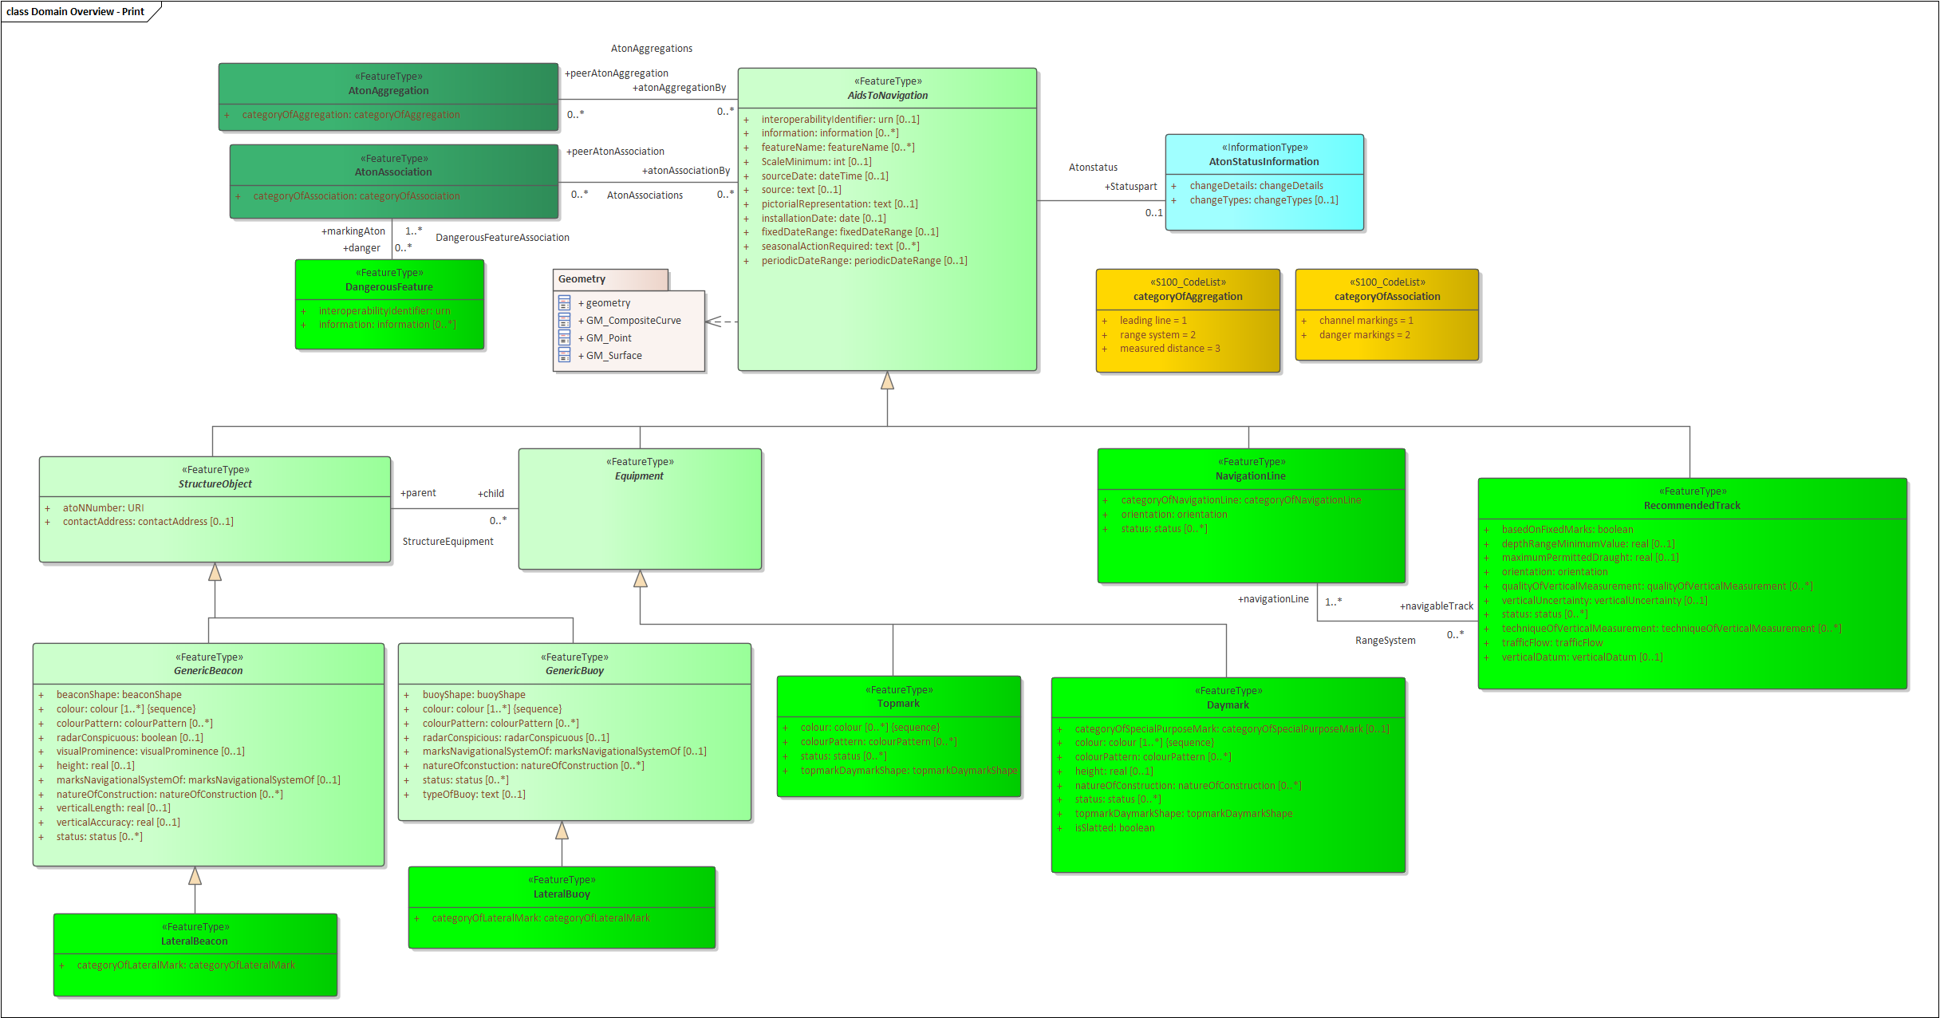

Figure 1. Overview of Feature types

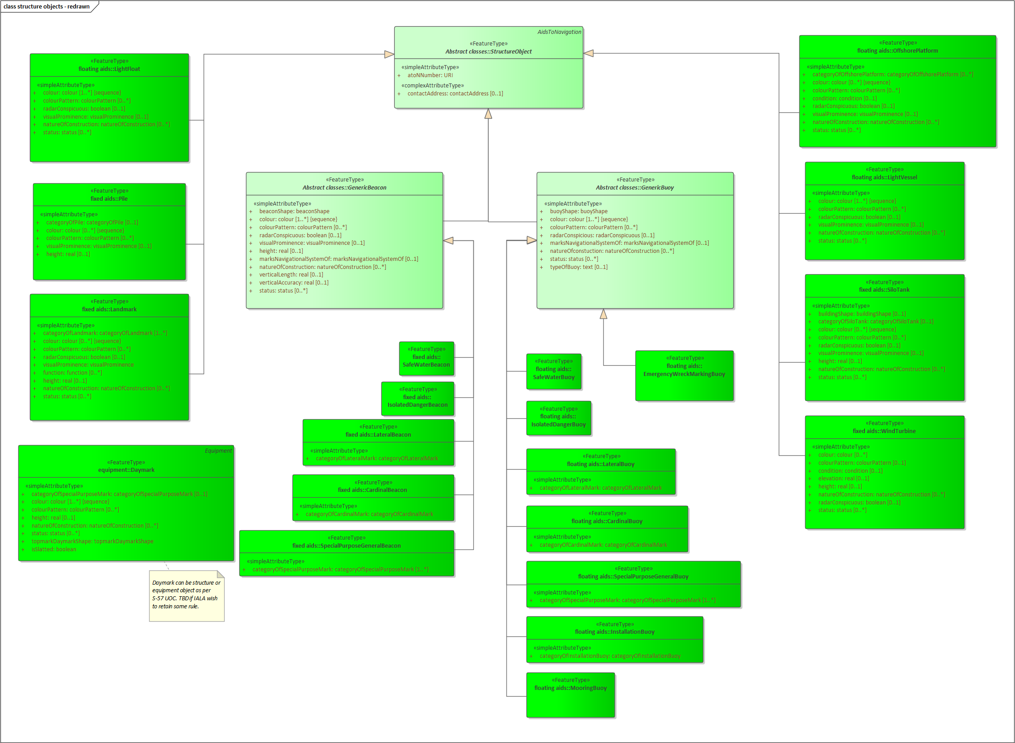
Figure 2. Structure Feature Types
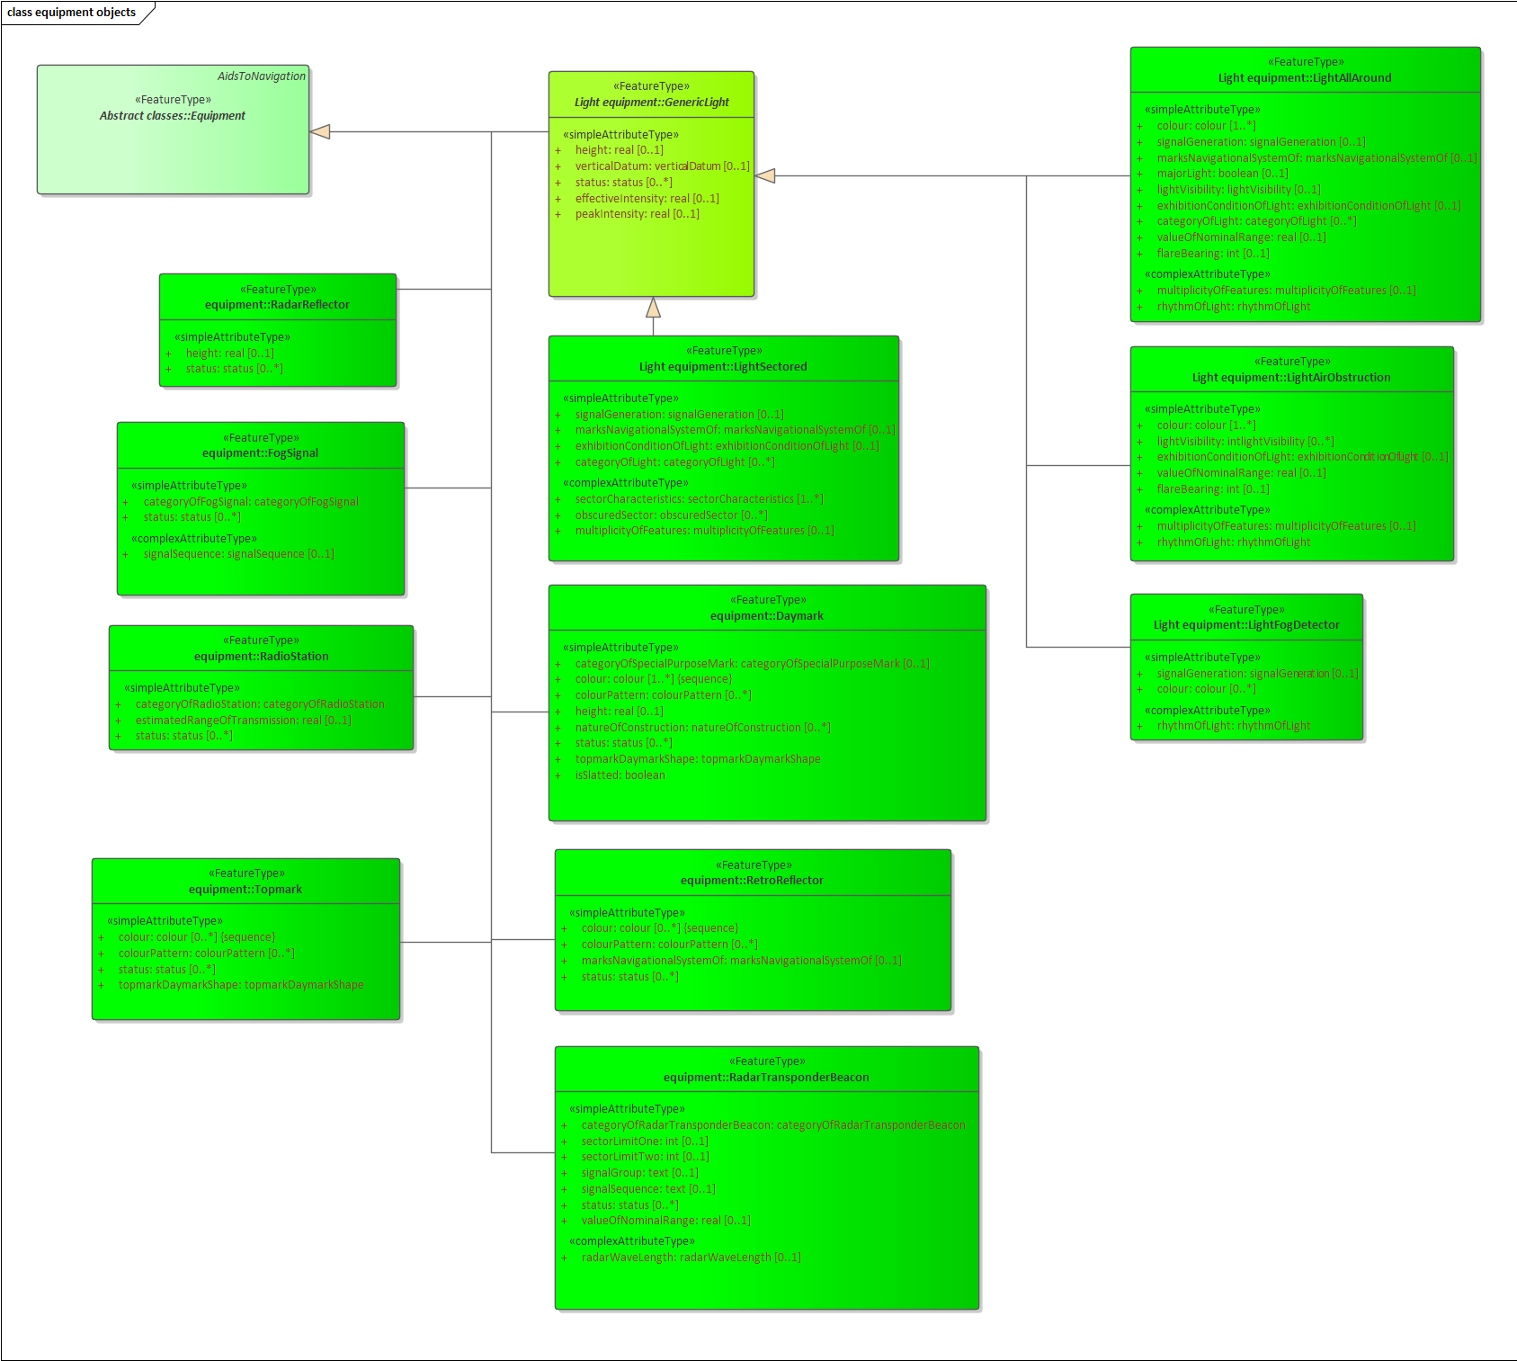
Figure 3. Equipment Feature Types

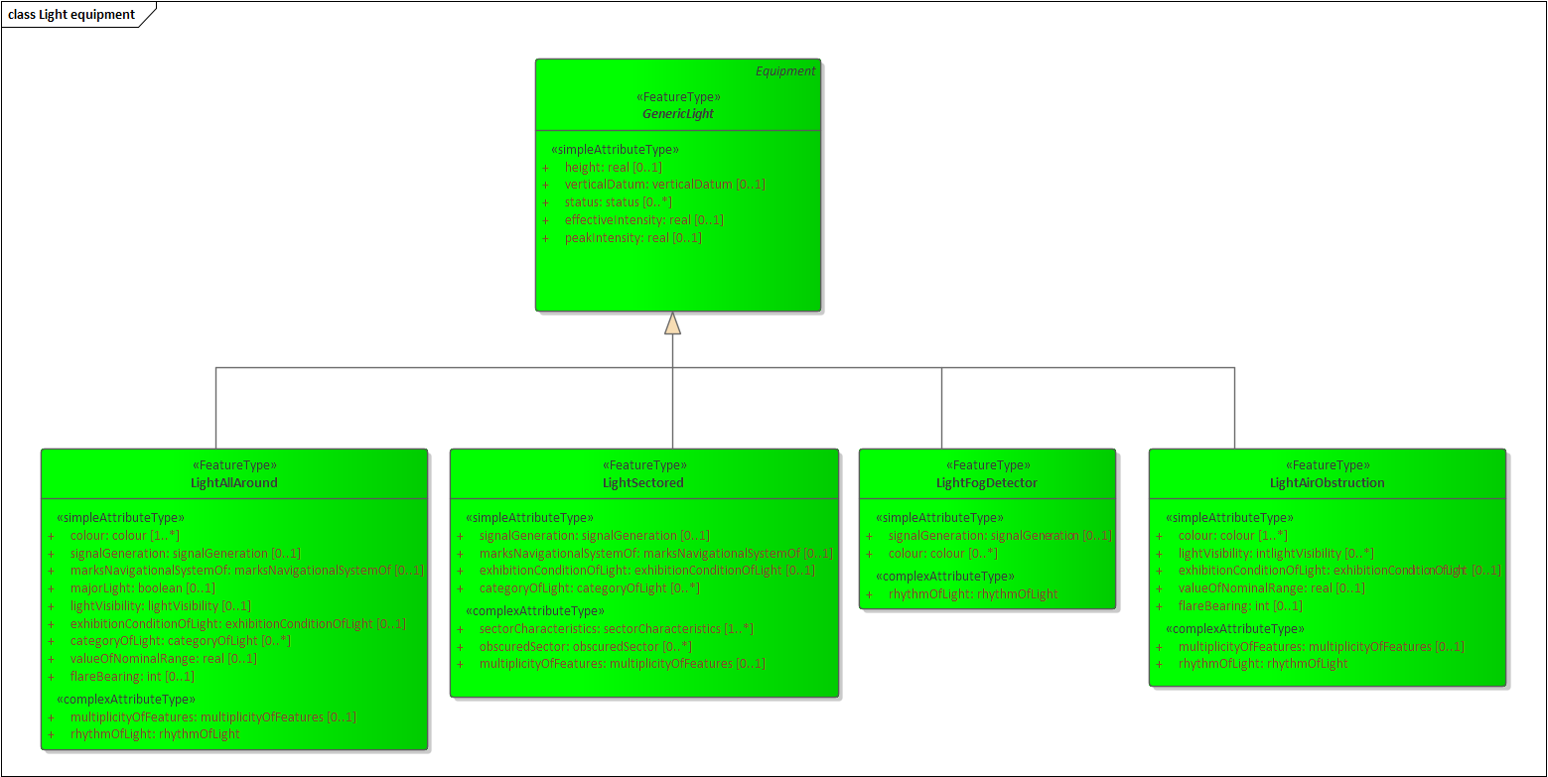
Figure 4. Light Feature Types

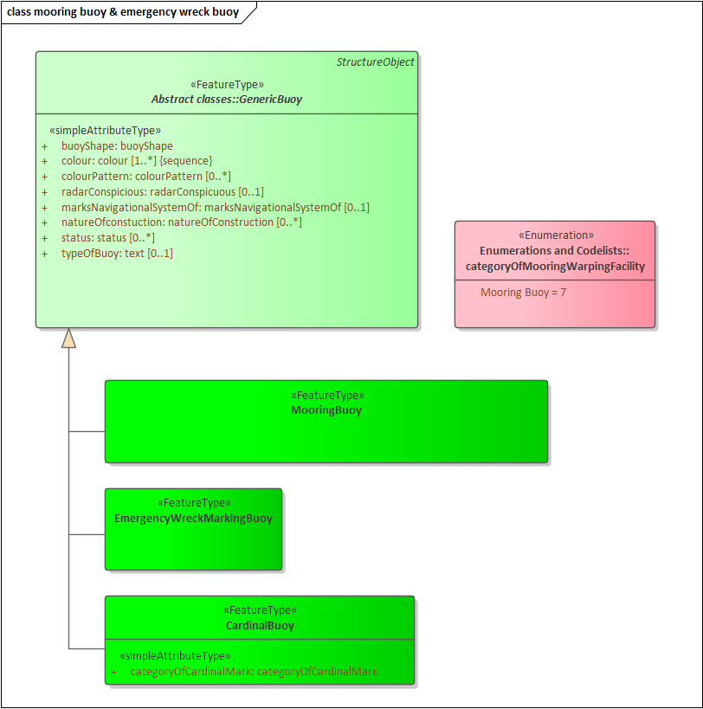
Figure 5. Mooring Buoy and Emergency Wreck Marking Buoy Feature Types

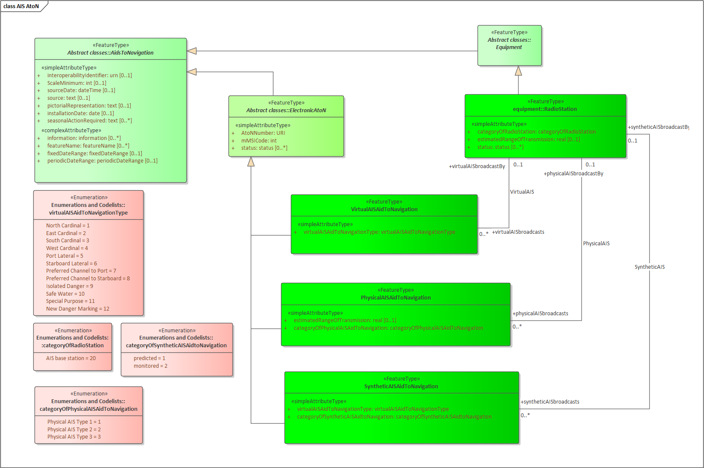
Figure 6. AIS Feature Types

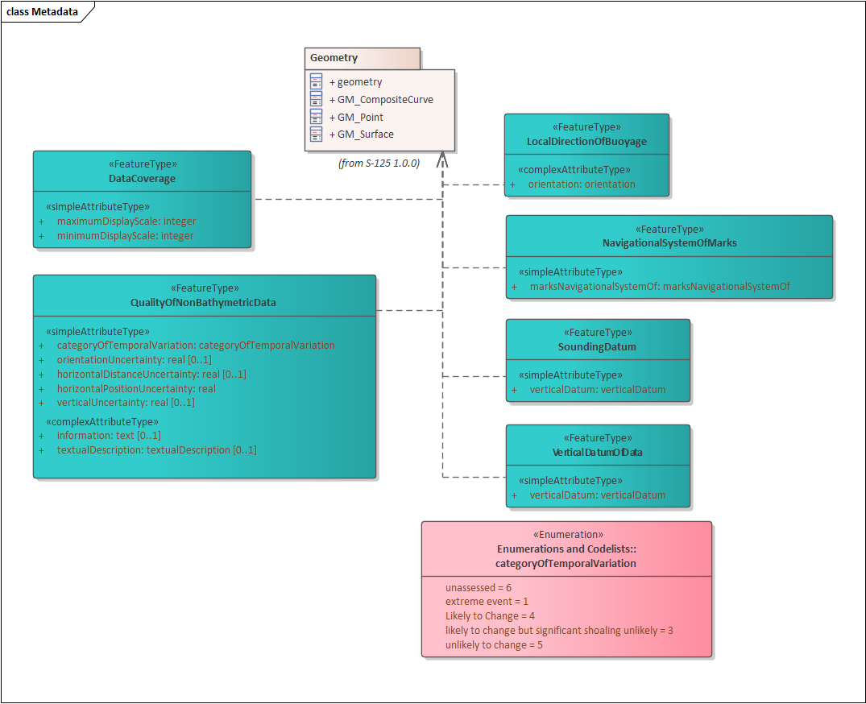
Figure 7. Meta Feature Types

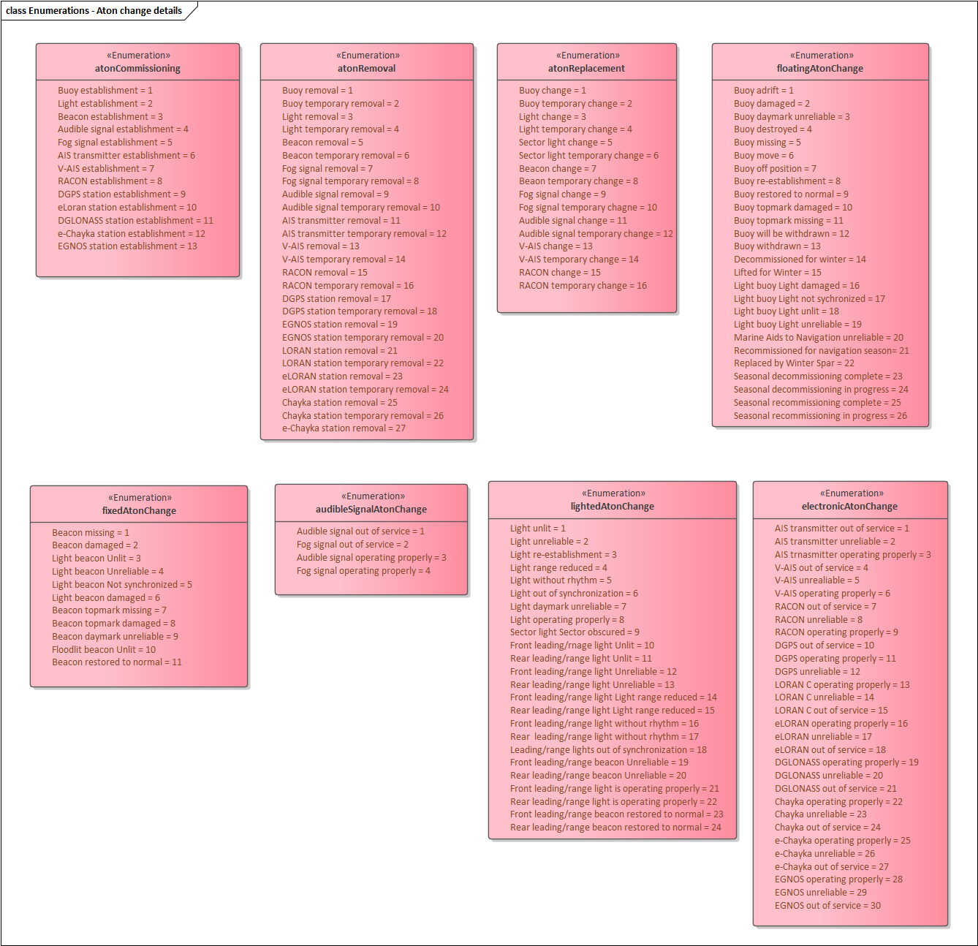
Figure 8. Aton change details Enumeration

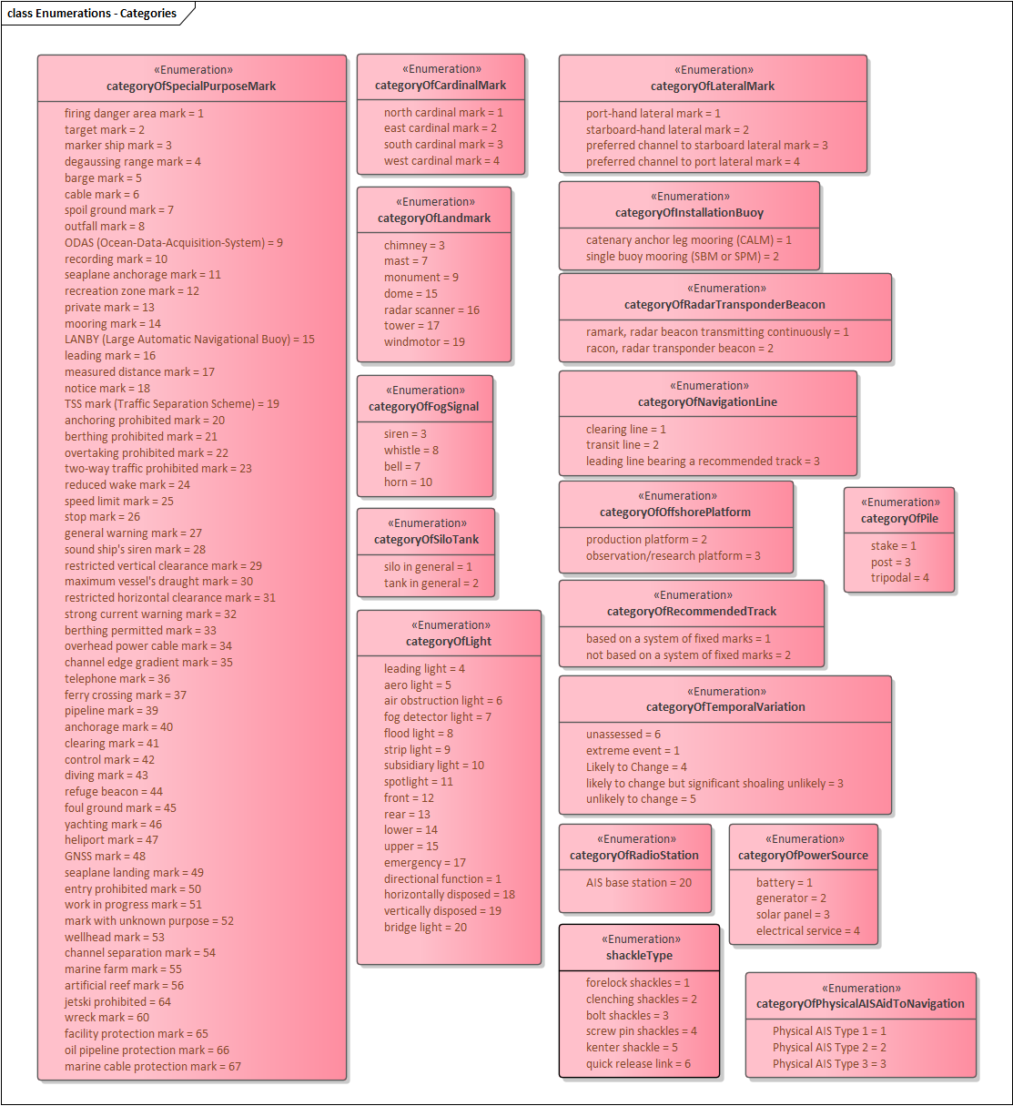
Figure 9. Categories Enumeration

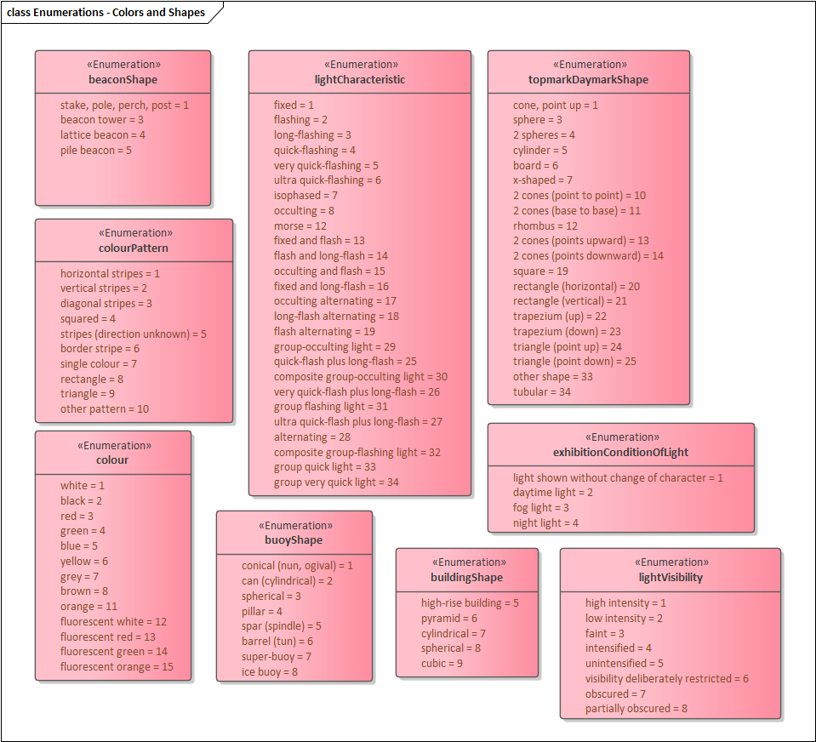
Figure 10. Colors and Shapes Enumeration

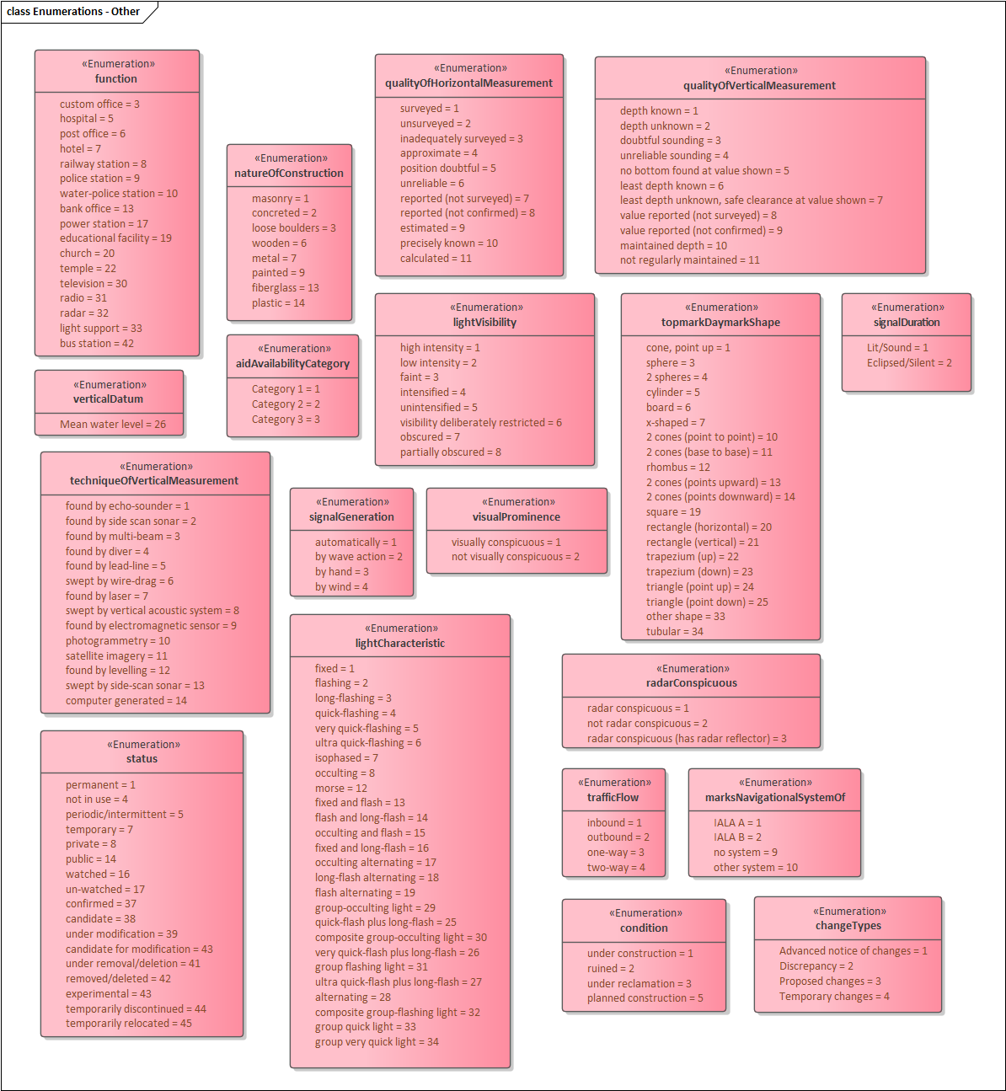
Figure 11. Others Enumeration

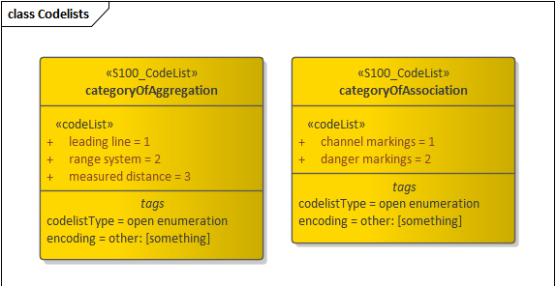
Figure 12. Code lists

Feature Catalogue

Introduction
The Feature Catalogue describes the feature types, information types, attributes, attribute values, associations and roles which may be used in the product. The S-125 Feature Catalogue is available in an XML document which conforms to the S-100 XML Feature Catalogue Schema and can be downloaded from the IHO website (https://iho.int). Simple attributes used in this specification are listed below.

Name: Marine Aids to Navigation (AtoN)
Scope: Ocean, Coastal, Ports, Harbors and Inland waters
Version Number: 1.0.0
Version Date: 2025-04-03
Producer: International Hydrographic Organization (IHO),
4 quai Antoine 1er,
B.P. 445
MC 98011 MONACO CEDEX
Telephone: +377 93 10 81 00
Telefax: + 377 93 10 81 40
URL https://iho.int
Language: English

Feature Types
Feature types contain descriptive attributes that characterize real-world entities. The word ‘feature’ may be used in one of two senses – feature type and feature instance. A feature type is a class and is defined in a Feature Catalogue. A feature instance is a single occurrence of the feature type and represented as an object in a dataset. A feature instance is located by a relationship to one or more spatial instances. A feature instance may exist without referencing a spatial instance.

Geographic
Geographic (Geo) feature types carry the descriptive characteristics of a real world entity.

Meta
Meta features contain information about other features within a data set. Information defined by meta features override the default metadata values defined by the data set descriptive records. Meta attribution on individual features overrides attribution on meta features.

Feature Relationship
A feature relationship links instances of one feature type with instances of the same or a different feature type.

Information Types
Information types are identifiable pieces of information in a dataset that can be shared between other features. They have attributes but have no relationship to any geometry; information types may reference other information types.

Attributes
S-125 defines attributes as either simple or complex.

Simple Attributes
S-125 uses ten types of simple attributes; they are listed in the Table below.

Type | Definition
Enumeration | A fixed list of valid identifiers of named literal values.
Boolean | A value representing binary logic. The value can be either True or False. The default state for Boolean type attributes (i.e. where the attribute is not populated for the feature) is False.
Real | A signed Real (floating point) number consisting of a mantissa and an exponent.
Integer | A signed integer number. The representation of an integer is encapsulation and usage dependent.
CharacterString | An arbitrary-length sequence of characters including accents and special characters from a repertoire of one of the adopted character sets.
Date | A date provides values for year, month, and day according to the Gregorian Calendar. Character encoding of a date is a string which must follow the calendar date format (complete representation, basic format) for date specified by ISO 8601:1988.  EXAMPLE 19980918 (YYYY-MM-DD)
Time | A time is given by an hour, minute, and second. Character encoding of a time is a string that follows the local time (complete representation, basic format) format defined in ISO 8601:1988.  EXAMPLE 183059 or 183059+0100 or 183059Z
Date and Time | A DateTime is a combination of a date and a time type. Character encoding of a DateTime shall follow ISO 8601:1988.  EXAMPLE 19850412T101530
Codelist | A type of flexible enumeration. A code list type is a list of literals which may be extended only in conformance with specified rules.
Truncated date | One or more components of the Date type are omitted.
Table 7-1. Simple feature attributes.

Complex Attributes
Complex attributes are aggregations of other attributes that are either simple or complex. The aggregation is defined by means of attribute bindings.
Figure 13. textContent – a complex attribute

Geometric Representation
Geometric representation is the digital description of the spatial component of an object as described in S-100 and ISO 19107. This product specification uses three types of geometries: GM_Point, GM_OrientableCurve, and GM_OrientableSurface.

Coordinate Reference System (CRS)

Introduction
The location of an object in the S-100 standard is defined by means of coordinates which relate a feature to a position. The coordinate reference system used for this product specification is World Geodetic System 1984 (WGS 84) which is defined by the European Petroleum Survey Group (EPSG) code 4326, (or similar - North American Datum 1983 / Canadian Spatial Reference System).

Spatial data is expressed as latitude (φ) and longitude (λ) geographic coordinates. Latitude values are stored as a negative number to represent a position south of the Equator. Longitude values are stored as a negative number to represent a position west of the International Prime Meridian. Coordinates are expressed as real value, degree / degree decimal format. Datasets conforming to this product specification are not projected.

Horizontal coordinate reference system: WGS 84
Projection: None
Vertical coordinate reference system: None

Temporal reference system: Gregorian calendar
Coordinate reference system registry: EPSG Geodetic Parameter Registry

Date type (according to ISO 19115): 002 - publication

Horizontal reference system

Positional data is expressed in latitude and longitude geographic coordinates of the World Geodetic System 84 (WGS 84).

Projection
Marine AtoN data products are un-projected.

Vertical coordinate reference system
Marine Aids to Navigation (AtoN) data products do not provide detailed vertical information.

Temporal reference system
Time is measured by reference to Calendar dates and Clock time in accordance with ISO 19108:2002 Temporal Schema section 5.4.4.

Coverage of nautical products data and scale
Marine AtoN data must be compiled in the best applicable scale. The use of the data itself is "scale independent". That means that the data can be used at any scale. S-100 allows the association of multiple spatial attributes to a single feature instance. Each of these spatial attributes can in principle be qualified by maximum and minimum scales.
For example, it is possible, within one dataset, to have a single instance of a feature that has more than one area geometry. Each of these geometries has different scale max/min attributes. Moreover, due to cluttering in smaller scales, the scale minimum attribute may be used to turn off portrayal of some features at smaller scales.

Data Quality

Data quality allows users and user systems to assess fitness for use of the provided data. Data quality measures and the associated evaluation are reported as metadata of a data product. This metadata improves interoperability with other data products and provides usage by user groups that the data product was not originally intended for. The secondary users can make assessments of the data product usefulness in their application based on the reported data quality measures.
For S-125 the following data quality elements have been included:
- Conformance to this Product Specification;
- Intended purpose of the data product;
- Completeness of the data product in terms of coverage;
- Logical Consistency;
- Positional Uncertainty and Accuracy;
- Thematic Accuracy;
- Temporal Quality;
- Aggregation measures;
- Elements specifically required for the data product (none currently identified for S-125);
- Validation checks or conformance checks including:
  - General tests for dataset integrity;
  - Specific tests for a specific data model.

Data Capture and Classification

Data source: S-125 products must be based on data sources released by an appropriate authority such as AtoN authority and Hydrographic Offices. Data source should be described in each data product. The production process used to generate Marine AtoN products may be described in the comment attribute of the dataset metadata.

Item Name | Description | Multiplicity | Type
dataSource | Identification of the kinds of data sources usable to product datasets compliant with the  considering specification | 0..* | CharacterString
productionProcess | Link to a textual description of the production process (including encoding guide) applicable to the datasets compliant with the  considering specification | 0..* | CharacterString (URL)
Table 10-1. Data capture information

Data Encoding and Product Delivery

Data Encoding
The principal encoding will be the Open Geospatial Consortium (OGC), Geography Markup Language (GML) format. GML is an XML grammar designed to express geographical features. It serves as a modeling language for geographic systems as well as an open interchange format for geographic transactions.

Types of Datasets
A dataset is a grouping of features, attributes, geometry, and metadata which comprises a specific coverage. The following lists the types of Marine AtoN datasets which may be produced and contained within an exchange set:

Dataset | Explanations
New dataset (base dataset): | Data for an area different (in coverage and/or extent) to existing datasets.
New Edition of a dataset: | A re-issue plus new information which has not been previously distributed by Updates. Each New Edition of a dataset must have the same name as the dataset that it replaces and should have the same spatial extents. The edition number in the dataset discovery metadata shall increment up by one from the previous edition.
Update dataset | A data replacement of the latest edition of a dataset.
Cancellation | Used to cancel dataset and any related update datasets.
Table 10-2. Marine AtoN dataset types

Content of Update Datasets
Update datasets can only contain replacements, deletions, and additions of whole feature instances or information instances. This means that when a feature or information instance is updated, the new version must contain all the attributes of the old instance, including any inline spatial attributes (i.e., inline geometry), except those attributes that are being removed.

An association to an instance of a feature or information type is treated as an attribute of the referring instance, and therefore adding or deleting an association means the original referring instance must be replaced with a new version. The instance at the other end of the association needs to be replaced if and only if it contains a reference to the first instance.

Spatial objects that are not inline (i.e., geometry that is encoded as an independent spatial object in the dataset) are treated like any other object, i.e., it needs to be updated if and only if the primitive has changed (e.g., a coordinate is updated).

Feature and information type instances are deleted without replacement by setting the fixedDateRange.dateEnd attribute of the instance to the date of deletion, which will usually be the issue date of the update.

Encoding of Latitude and Longitude
Values should be encoded as decimal numbers with 7 or fewer digits after the decimal. The normative encoding is in degrees, with an accuracy of 10⁻⁷ degrees, i.e., 7 digits after the decimal point.
The decimal point must be indicated by the “.” character.
Trailing zeroes after the decimal point (and the decimal point itself if appropriate) may be omitted at producer discretion, but the accuracy must still be as indicated (e.g., 10⁻⁷ degrees for coordinates of default accuracy).
Latitude and longitude multiplication factors held in the Dataset Structure Information field under [coordMultFactorX] and [coordMultFactorY] must be set to a value corresponding to the encoding, e.g., {1} for coordinates encoded in decimal degrees.
Example: A longitude = 42.0000 is converted into X = longitude * coordMultFactorX = 42.0000 * 1 = 42.0000000.

Numeric Attribute Encoding
Floating point and integer attribute values must not contain leading zeros. Floating point attribute values must not contain non-significant trailing zeros.

Text Attribute Values
Character strings must be encoded using the character set defined in ISO 10646-1, in Unicode Transformation Format-8 (UTF-8).

Mandatory Attribute Values
There are four reasons why attribute values may be considered mandatory:
- They determine whether a feature is in the display base.
- Certain features make no logical sense without specific attributes.
- Some attributes are necessary to determine which symbol is to be displayed.
- Some attributes are required for safety of navigation.
All mandatory attributes are identified in the Feature Catalogue and summarized in Annex A – Data Classification and Encoding Guide.

Unknown Attribute Values
When a mandatory attribute code or tag is present, but the attribute value is missing, it means that the producer wishes to indicate that this attribute value is unknown. Missing mandatory attributes must be “nilled” with a GML nilReason attribute giving the reason for omission.
Optional attributes must be omitted altogether if the value is unknown or missing. They must not be “nilled.”
Example: An isolated danger beacon feature has unknown color (mandatory attribute) and condition (optional attribute). The feature could be coded as:
<BeaconIsolatedDanger>
<beaconShape>beacon tower</beaconShape>
<colour nilReason=”unknown”/>
… other attributes…
… <condition> is NOT coded …
</BeaconIsolatedDanger>

Structure of dataset files
The order of data objects in each dataset file is described below:

Dataset Identification Information
Dataset structure information
Spatial records for by-reference geometries
Point
Curve
Composite Curve
Information objects
Feature objects (Geometry may be encoded inline or by reference.)
Meta features
Geo features

Object identifiers
Features, information types, collection objects, meta features, and geometries (inline or external) are all required by the schema to have a gml:id attribute with a value that is unique within the dataset. The gml:id values must be used as the reference for the object from another object in the same dataset or another dataset.

All geographic feature classes in S-125 have the idCode attribute. This attribute shall be used to hold the Maritime Resource Name (MRN) identifier for the feature instance.

Data coverage
All areas of a dataset must be covered by a DataCoverage meta feature.

An update dataset must not change the limit of a DataCoverage feature for the base dataset. Where the limit of a DataCoverage feature for a base dataset is to be changed, this must be done by issuing a new edition of the dataset.

Data overlap
S-125 datasets can overlap other S-125 datasets.

Data extent
Datasets must not cross the 180° meridian of longitude.

Data Delivery

Data Product Delivery Information
This data product specification defines GML as the primary format in which Marine AtoN data products are delivered. The delivery format is described by the following items (from ISO 19131:2005): format name, version, specification, language, and character set.

Name | ISO 19131 Elements | Value
Format name | DPS_DeliveryInformation.deliveryFormat > DPS_DeliveryFormat.formatName | GML*
Version | DPS_DeliveryInformation.deliveryFormat > DPS_DeliveryFormat.version | 3.2.1
Specification description | DPS_DeliveryInformation.deliveryFormat > DPS_DeliveryFormat.specification | GML*
Language | DPS_DeliveryInformation.deliveryFormat > DPS_DeliveryFormat.language | English
Character set | DPS_DeliveryInformation.deliveryFormat > DPS_DeliveryFormat.characterSet > MD_CharacterSetCode | 004 – utf8
Table 11-1. Data product delivery format
* GML is an XML encoding for the transport and storage of geographic information, including both the geometry and the properties of geographic features, between distributed systems. The XML Schema for the GML application schema is provided in a schema document S125.xsd which imports other schema(s) defining common types. These files are available in the IHO Geospatial Information Registry. Feature instance shall validate against S125.xsd and conform to all other requirements specified in this data product specification including all constraints not captured in the XML Schema document.

Dataset loading
New datasets must always replace old datasets.

New editions
When a new edition of a dataset is received, the system must replace the previous edition, along with any updates, with the new edition of the dataset.

Dataset size
Marine AtoN datasets must not exceed 10MB in accordance with other S-100 products displayed on ECDIS.

Exchange Set
Data which conforms to this product specification must be delivered by means of an exchange set. An exchange set will consist of one or more Marine AtoN datasets. An exchange set may also include one or more support files containing supplementary information encoded in separate files. These are linked to the Marine AtoN dataset features, by feature and information type attributes defined in the application schema, e.g., fileReference. Each exchange set will include a single (XML) exchange catalogue file. S-125 exchange set catalogues conform to S-100 Part 17 without modification, containing discovery metadata for each Marine AtoN dataset as well as support files. S-125 exchange set structure conforms to S-100 Part 17 without modification.

Support Files

Support files contain ancillary textual or graphic information in separate (linked to the dataset) files. The following formats are allowed for support files:

- Text files must contain only UTF-8 encoded text as defined by this standard (text consisting only of printable characters and without HTML, XML, or other markup).
- Picture files must be in TIFF Revision 6.0 (TIFF).

Support files shall be used for data management and additional information to users. Portraying and using support files in ECDIS or other systems is not mandatory.

Support File Naming Convention

All support files will have unique world-wide file identifiers. The file identifier of support information should not be used to describe the physical content of the file. The support file metadata that accompanies the file will inform the user of the name and purpose of the file (new, replacement, and deletion).

In this encoding the support files are named according to the specifications given below:

125CCCCXXXXXXXXXX.YYY

The main part forms an identifier where:
- The first three characters are always “125” and identify the dataset as an S-125 dataset.
- The next four characters identify the issuing agency by its alphanumeric agency code in the IHO producer code register in the IHO GI Registry (i.e., the IHO is identified as “AA”, not “1810”). Where the agency code consists of fewer than four characters, sufficient zeros must be suffixed to make the length exactly four characters (e.g., “AA00” for IHO).
- The eighth up to the seventeenth character can be used in any way by the producer to provide a unique file name for the dataset. The following characters are allowed in the dataset name. A to Z, 0 to 9, and the special character _ (underscore). The ninth through seventeenth characters are optional (i.e., at least one character must be used).
- .YYY – support file extension.

Dataset Naming Convention
All dataset files will have unique world-wide file identifiers. The file identifier of the dataset should not be used to describe the physical content of the file. The dataset file metadata that accompanies the file will inform the user of the name and purpose of the file (new, replacement, and deletion).
In this encoding the dataset files are named according to the specifications given below:

125CCCCXXXXXXXXXX.GML

The main part forms an identifier where:
- The first three characters are always “125” and identify the dataset as an S-125 dataset.
- The next four characters identify the issuing agency by its alphanumeric agency code in the IHO producer code register in the IHO GI Registry (i.e., the IHO is identified as “AA”, not “1810”). Where the agency code consists of fewer than four characters, sufficient zeros must be suffixed to make the length exactly four characters (e.g., “AA00” for IHO).
- The eighth up to the seventeenth character can be used in any way by the producer to provide a unique file name for the dataset. The following characters are allowed in the dataset name, A to Z, 0 to 9 and the special character _ (underscore). The ninth through seventeenth characters are optional (i.e., at least one character must be used).

Update dataset naming convention
All update dataset files will have an identical name to the base dataset, aside from the separator and update number sequence.

In this encoding the update dataset files are named according to the specifications given below:

125CCCCXXXXXXXXXX_XXX.GML

The main part forms an identifier where:

- The first up to the seventeenth characters are the same as the dataset being updated and therefore conform to the rules described in section 11.6.
- The next character must be an underscore “_”.
- The next three characters must be numerical (0-9) characters to indicate the place of the update dataset in the update sequence.

Catalogue File Naming Convention
The exchange catalogue acts as the table of contents for the exchange set. The catalogue file of the exchange set must be named CATALOG.XML. No other file in the exchange set may be named CATALOG.XML. The content of the exchange catalogue file is described in S-100 Part 17.

Dataset Maintenance

Introduction
Datasets are maintained as needed and must include mechanisms for Marine AtoN updating. Data updates will be made by new editions or updates. The maintenance and update frequency of Marine AtoN datasets should be defined by the producers (official national authority) implementing this specification. Data Producers must use applicable sources to maintain and update data and provide a brief description of the sources that were used to produce the dataset in the appropriate metadata field.

Production process for base and update datasets
Data Producers should follow their established production processes for maintaining and updating datasets. Data is produced against the DCEG and checked against the appropriate set of validation rules in Appendix A.

Dataset updates and cancellation
The purpose of issue of the dataset is indicated in the “purpose” field of the dataset discovery metadata.

Cancellation should be in line with the functionality documented in S-100 Ed 5.2. Where a dataset is cancelled and its name is reused at a later date, the issue date must be greater than the issue date of the cancelled dataset. When the dataset is cancelled, it must be removed from the system.

An exchange set may contain base dataset files and update dataset files for the same datasets. Under these circumstances the update dataset files must follow in the correct sequential order from the last update applied to the base dataset file.

Support file updates
The purpose of issue is indicated in the “purpose” field of the support file discovery metadata. Support files carrying the “deletion” flag in exchange catalogue metadata must be removed from the system. When a feature or information type pointing to a text, picture, or application file is deleted or updated so that it no longer references the file, the system software must check to see whether any other feature or information type references the same file, before that file is deleted.

Updates, in form of a new edition or a replacement, or deletions of a support file may require concurrent updates to feature or information type instance attributes that depend on the file, e.g., pictorialRepresentation, fileReference, and fileLocator attributes.

Feature and portrayal catalogues
For each new version of the S-125 Product Specification a new feature and portrayal catalogue may be released. The system must be able to manage datasets and their catalogues that are created on different versions of the S-125 product specification.

Feature history, versions, and change tracking
If applications or production systems require versioning of individual instances of feature or information types, maintenance of histories, or change tracking, the methods for versioning, history management, and change tracking and display are left to the application or production system.

Dataset encryption
Datasets may be encrypted according to S-100 Part 15.

Portrayal
The Portrayal Catalogue is found at Annex D.

Metadata

Introduction
The Marine AtoN metadata specification conforms to the S-100 metadata specification in Part 4a, which is a profile of the ISO 19115-1 standard. These documents provide a structure for describing digital geographic data and define metadata elements, a common set of metadata terminology, definitions, and extension procedures.

The overall structure of metadata in S-125 exchange sets is the same as in S-100. Metadata in exchange sets consists of discovery metadata for the datasets and support files in the exchange set (classes S100_DatasetDiscoveryMetadata and S100_SupportFileDiscoveryMetadata), metadata in ISO 19115-1 format for datasets, and metadata about any feature, portrayal, or interoperability catalogues which are in the exchange set (S100_CatalogueMetadata).

The discovery metadata classes have numerous attributes which enable important information about the datasets and accompanying support files to be examined without the need to process the data, for example decrypt, decompress, load, etc. Other catalogues such as feature and portrayal catalogues can be included in the exchange set in support of the datasets.

Since the class S100_DatasetDiscoveryMetadata aggregates ISO 19115 metadata (class S100_19115DatasetMetadata), metadata conforming to ISO 19115 is required to be included. Metadata for each support file is required if the exchange set contains support files.

Metadata classes
Details for the S-100 metadata classes are depicted in S-100 Part 17.

Appendix A
S-125 Maintenance - Change Proposal Form
(normative)

Organization Date

Contact Email

Change Proposal Type Select only one option

1.Clarification 2.Revision 3.New Edition

Location Identify all change proposal locations

S-125 Version No. Part No. Section No. Proposal Summary

Change Proposal

Please provide a detailed change proposal.

Change Proposal Justification

Please provide a suitable explanation for the change and where applicable supporting documentation.

Please send completed forms and supporting documentation to the IHO Secretariat
(addt@iho.int).

